Paper Formatting Guidelines for the Fourth EURASIP Workshop on RFID Technology (RFID2012)

First A. Author
Author’s Affiliation
Town, Country
email@address.com
Second B. Author
Author’s Affiliation
Town, Country
email@address.com
Third C. Author
Author’s Affiliation
Town, Country
email@address.com

Abstract – The abstract should concisely describe the contents of the submission, without the use of references, tables, or figures. The length of the abstract should not exceed 150 words.

I. Introduction
This document describes the procedure for preparing submissions for the Fourth International EURASIP Workshop on RFID Technology. By adhering to these guidelines, the authors ensure optimum presentation of their work and help the organizing committee achieve consistent appearance of the final proceedings.
This template is intended for use with Microsoft Word versions 6.0 or later. For an electronic version of this document, please point your browser to http://www.polito.it/EURASIP-RFID2012/ submission.html. A template for the LaTeX document preparation system is also available at this location.

II. Formatting the Paper
All submissions should be prepared in English, on A4 paper, using 20mm for the top and bottom margins, and 15mm for the side margins. The body of the document should be formatted into two equal columns, both of which should be fully (left and right) justified, with a separation of 4mm between the columns.
The only font used throughout the document should be Times New Roman. This applies to all paragraph text, titles, abstract, figures, captions, and references. For prescribed font sizes and styles, please refer to Table 1.
Table 1 - Prescribed font sizes and styles
Text | Size | Style
Title | 22 | normal
Author | 11 | italic
Abstract | 9 | bold
Body | 9 | normal
Section | 11 | small caps
Sub-Section | 10 | bold
Caption | 9 | small caps
Reference | 9 | normal

Throughout the submission, please emphasize text using bold formatting.

III. Required Sections
The Abstract and References sections are required for each submission and are not numbered. The abstract should appear directly below the authors names, and provide a succinct summary of the paper in no more than 150 words.
All citations in the submission should be listed in the Reference section, which should appear at the end of the submission. Please number citations consecutively (i.e. in the order they appear in the text), using square brackets [1]. For multiple citations, either indicate intervals with a hyphen [2-4] or separate them using commas [1,4]. In the Reference section please only include citations that have been referenced in the text.

IV. Other Hints

4.1 Figures
When using figures, please make sure that their width is equal to that of the text column they belong to (i.e. 88mm), and that they are aligned with the margins of the text column. Also, please include a caption with each figure and make sure to refer to the figure at least once in the text. An example of the proper use of figures is given in Figure 1.
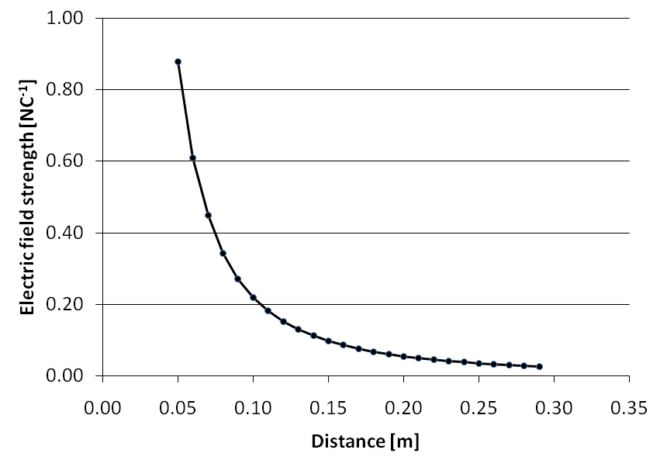
Figure 1 - Electric field strength of a point charge as a function of distance

Acknowledgements
In this optional section, the authors are free to acknowledge academic or industrial cooperation that enabled them to complete the presented work. The acknowledgement section is not numbered.

References
[1] T. H. Cormen, C. E. Leiserson, and R. L. Rivest. Introduction to Algorithms. The MIT Press, 2000. ISBN 0-07-013143-0.
[2] G.E. Moore. Cramming more components onto integrated circuits. Electronics Magazine, 38(8):114–117, April 1965.
[3] R. Subramanian. Shannon vs. Moore: Driving the Evolution of Signal Processing Platforms in Wireless Communications. In IEEE Workshop on Signal Processing Systems SIPS’02, October 2002.
[4] W3 Extensible Markup Language (XML). www.w3.org/XML.

